Project Linear Regression

Viswanth

20 October 2017

library(psych)  
library(car)

##   
## Attaching package: 'car'

## The following object is masked from 'package:psych':  
##   
## logit

#1.Describe data of response variable and predictors in terms of key summary statistics like mean, mode, median, standard deviation, range, skewness and kurtosis. Show histogram and box plots also for each variables. [hint: describe command in R]  
#Each variable to be explained in 30 words maximum.

grades<-read.csv(file.choose())  
dim(grades)

## [1] 105 22

colnames(grades)

## [1] "Sr_No" "id" "lastname" "firstname" "gender"   
## [6] "ethnicity" "year" "lowup" "section" "gpa"   
## [11] "extrc" "review" "quiz1" "quiz2" "quiz3"   
## [16] "quiz4" "quiz5" "final" "total" "percent"   
## [21] "grade" "passfail"

names(grades)

## [1] "Sr_No" "id" "lastname" "firstname" "gender"   
## [6] "ethnicity" "year" "lowup" "section" "gpa"   
## [11] "extrc" "review" "quiz1" "quiz2" "quiz3"   
## [16] "quiz4" "quiz5" "final" "total" "percent"   
## [21] "grade" "passfail"

hist(grades$gpa, main = "Histogram of GPA", xlab = "GPA", ylab = "Frequency", col = "Blue")

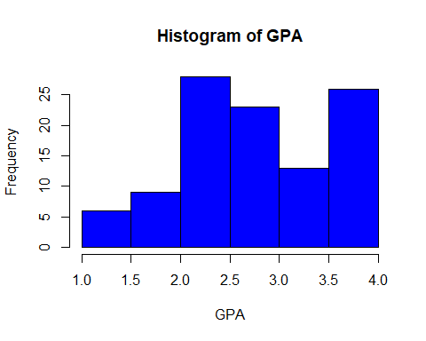

boxplot(grades$gpa, main = "Box plot of GPA", xlab = "GPA", col = "Blue", horizontal = T)

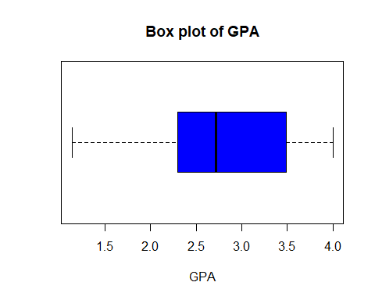

stem(grades$gpa)

##   
## The decimal point is 1 digit(s) to the left of the |  
##   
## 10 | 48  
## 12 | 443  
## 14 | 0  
## 16 | 1677  
## 18 | 04515  
## 20 | 23919  
## 22 | 1225780123445788  
## 24 | 03356671446667  
## 26 | 1623477  
## 28 | 004480266  
## 30 | 1256379  
## 32 | 85  
## 34 | 2599334778  
## 36 | 460  
## 38 | 4400000000000058  
## 40 | 0

summary(grades$quiz1)

## Min. 1st Qu. Median Mean 3rd Qu. Max.   
## 0.000 6.000 8.000 7.467 10.000 10.000

describe(grades$quiz1)

## vars n mean sd median trimmed mad min max range skew kurtosis  
## X1 1 105 7.47 2.48 8 7.76 2.97 0 10 10 -0.83 0.04  
## se  
## X1 0.24

hist(grades$quiz1, main = "Histogram of quiz1", xlab = "Quiz1 Marks", ylab = "Marks", col = "Blue")

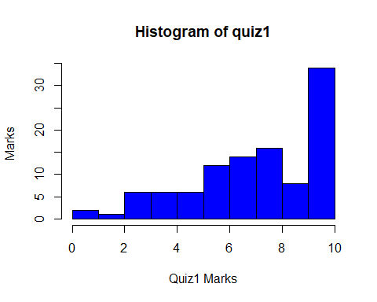

boxplot(grades$quiz1, main = "Box plot of Quiz1", xlab = "Quiz1", col = "Blue", horizontal = T)

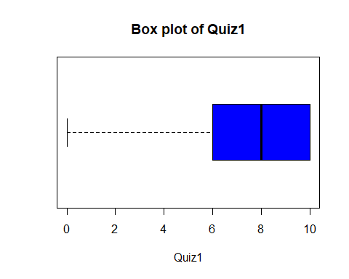

stem(grades$quiz1)

##   
## The decimal point is at the |  
##   
## 0 | 00  
## 1 |   
## 2 | 0  
## 3 | 000000  
## 4 | 000000  
## 5 | 000000  
## 6 | 000000000000  
## 7 | 00000000000000  
## 8 | 0000000000000000  
## 9 | 00000000  
## 10 | 0000000000000000000000000000000000

summary(grades$quiz2)

## Min. 1st Qu. Median Mean 3rd Qu. Max.   
## 3.000 7.000 8.000 7.981 9.000 10.000

describe(grades$quiz2)

## vars n mean sd median trimmed mad min max range skew kurtosis  
## X1 1 105 7.98 1.62 8 8.12 1.48 3 10 7 -0.64 -0.35  
## se  
## X1 0.16

hist(grades$quiz2, main = "Histogram of quiz2", xlab = "Quiz2 Marks", ylab = "Frequency", col = "Blue")

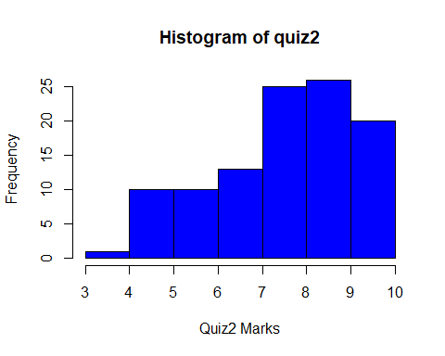

boxplot(grades$quiz2, main = "Box plot of Quiz2", xlab = "Quiz2", col = "Blue", horizontal = T)

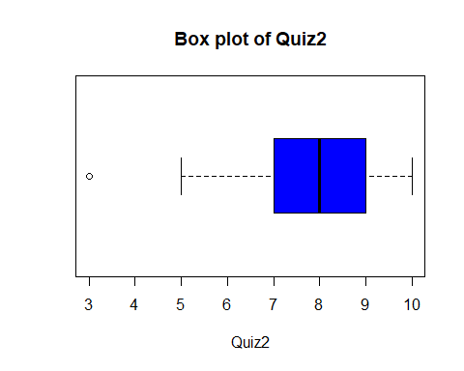

stem(grades$quiz2)

##   
## The decimal point is at the |  
##   
## 3 | 0  
## 3 |   
## 4 |   
## 4 |   
## 5 | 0000000000  
## 5 |   
## 6 | 0000000000  
## 6 |   
## 7 | 0000000000000  
## 7 |   
## 8 | 0000000000000000000000000  
## 8 |   
## 9 | 00000000000000000000000000  
## 9 |   
## 10 | 00000000000000000000

summary(grades$quiz3)

## Min. 1st Qu. Median Mean 3rd Qu. Max.   
## 0.000 6.000 9.000 7.981 10.000 10.000

describe(grades$quiz3)

## vars n mean sd median trimmed mad min max range skew kurtosis se  
## X1 1 105 7.98 2.31 9 8.34 1.48 0 10 10 -1.1 0.59 0.23

hist(grades$quiz3, main = "Histogram of quiz3", xlab = "Quiz3 Marks", ylab = "Frequency", col = "Blue")

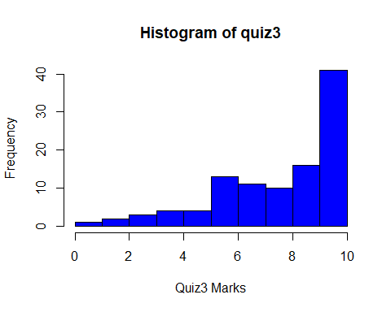

boxplot(grades$quiz3, main = "Box plot of Quiz3", xlab = "Quiz3", col = "Blue", horizontal = T)

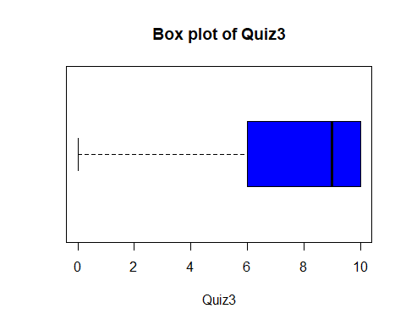

stem(grades$quiz3)

##   
## The decimal point is at the |  
##   
## 0 | 0  
## 1 |   
## 2 | 00  
## 3 | 000  
## 4 | 0000  
## 5 | 0000  
## 6 | 0000000000000  
## 7 | 00000000000  
## 8 | 0000000000  
## 9 | 0000000000000000  
## 10 | 00000000000000000000000000000000000000000

summary(grades$quiz4)

## Min. 1st Qu. Median Mean 3rd Qu. Max.   
## 2.0 6.0 8.0 7.8 10.0 10.0

describe(grades$quiz4)

## vars n mean sd median trimmed mad min max range skew kurtosis  
## X1 1 105 7.8 2.28 8 8.11 2.97 2 10 8 -0.89 -0.09  
## se  
## X1 0.22

hist(grades$quiz4, main = "Histogram of quiz4", xlab = "Quiz4 Marks", ylab = "Frequency", col = "Blue")

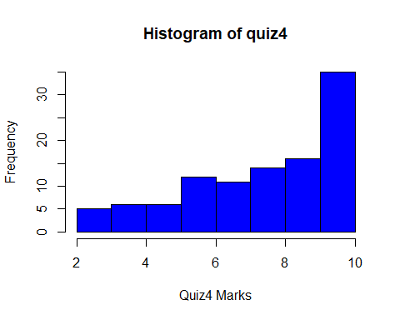

boxplot(grades$quiz4, main = "Box plot of Quiz4", xlab = "Quiz4", col = "Blue", horizontal = T)

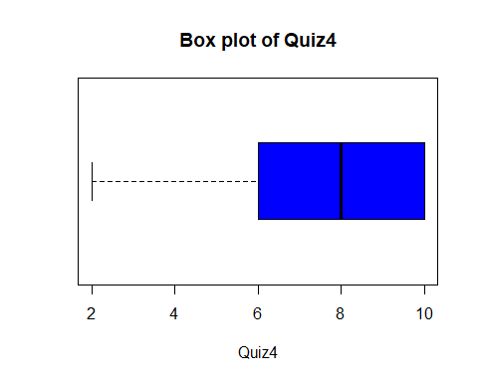

stem(grades$quiz4)

##   
## The decimal point is at the |  
##   
## 2 | 00000  
## 2 |   
## 3 |   
## 3 |   
## 4 | 000000  
## 4 |   
## 5 | 000000  
## 5 |   
## 6 | 000000000000  
## 6 |   
## 7 | 00000000000  
## 7 |   
## 8 | 00000000000000  
## 8 |   
## 9 | 0000000000000000  
## 9 |   
## 10 | 00000000000000000000000000000000000

summary(grades$quiz5)

## Min. 1st Qu. Median Mean 3rd Qu. Max.   
## 2.000 7.000 8.000 7.867 9.000 10.000

describe(grades$quiz5)

## vars n mean sd median trimmed mad min max range skew kurtosis  
## X1 1 105 7.87 1.77 8 8.02 1.48 2 10 8 -0.69 0.16  
## se  
## X1 0.17

hist(grades$quiz5, main = "Histogram of quiz5", xlab = "Quiz5 Marks", ylab = "Frequency", col = "Blue")

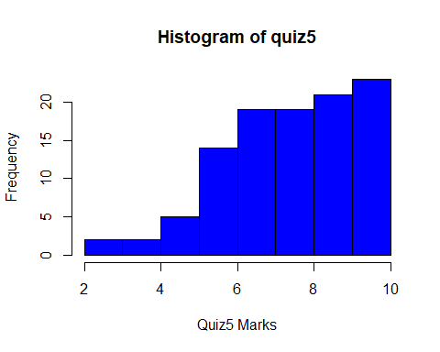

boxplot(grades$quiz5, main = "Box plot of Quiz5", xlab = "Quiz5", col = "Blue", horizontal = T)

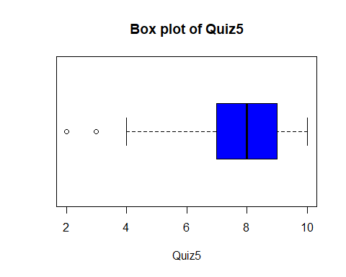

stem(grades$quiz5)

##   
## The decimal point is at the |  
##   
## 2 | 0  
## 2 |   
## 3 | 0  
## 3 |   
## 4 | 00  
## 4 |   
## 5 | 00000  
## 5 |   
## 6 | 00000000000000  
## 6 |   
## 7 | 0000000000000000000  
## 7 |   
## 8 | 0000000000000000000  
## 8 |   
## 9 | 000000000000000000000  
## 9 |   
## 10 | 00000000000000000000000

summary(grades$final)

## Min. 1st Qu. Median Mean 3rd Qu. Max.   
## 40.00 57.00 62.00 61.48 68.00 75.00

describe(grades$final)

## vars n mean sd median trimmed mad min max range skew kurtosis  
## X1 1 105 61.48 7.94 62 61.74 8.9 40 75 35 -0.33 -0.42  
## se  
## X1 0.78

hist(grades$final, main = "Histogram of final", xlab = "Final Marks", ylab = "Frequencys", col = "Blue")

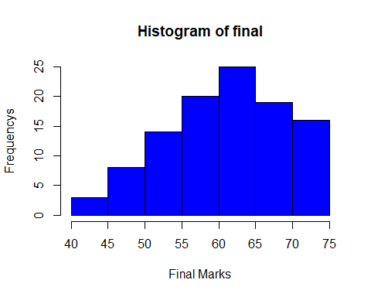

boxplot(grades$final, main = "Box plot of Final", xlab = "Fianl", col = "Blue", horizontal = T)

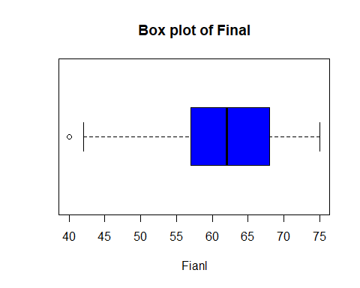

stem(grades$final)

##   
## The decimal point is at the |  
##   
## 40 | 0  
## 42 | 00  
## 44 |   
## 46 |   
## 48 | 00000  
## 50 | 000  
## 52 | 000000000  
## 54 | 00000  
## 56 | 0000000  
## 58 | 000000  
## 60 | 000000000000  
## 62 | 00000000000000  
## 64 | 000000  
## 66 | 0000000  
## 68 | 0000000000  
## 70 | 000000  
## 72 | 00000  
## 74 | 0000000

summary(grades$total)

## Min. 1st Qu. Median Mean 3rd Qu. Max.   
## 51.0 92.0 103.0 100.6 111.0 124.0

describe(grades$total)

## vars n mean sd median trimmed mad min max range skew kurtosis  
## X1 1 105 100.57 15.3 103 101.8 13.34 51 124 73 -0.81 0.77  
## se  
## X1 1.49

hist(grades$total, main = "Histogram of Total Marks", xlab = "Total Marks", ylab = "Frequency", col = "Blue")

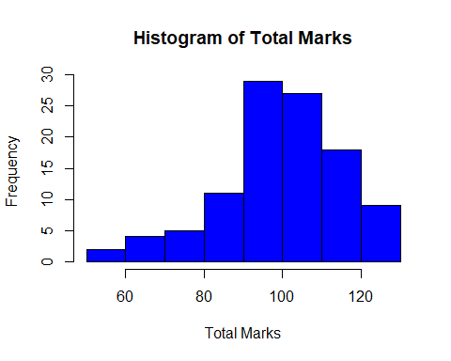

boxplot(grades$total, main = "Box plot of Total Marks", xlab = "Total", col = "Blue", horizontal = T)

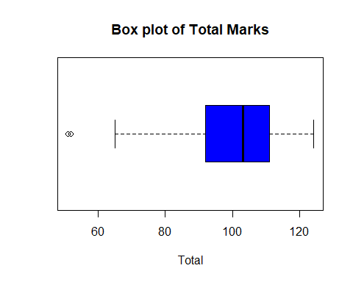

stem(grades$total)

##   
## The decimal point is 1 digit(s) to the right of the |  
##   
## 5 | 12  
## 5 |   
## 6 |   
## 6 | 56  
## 7 | 00  
## 7 | 5789  
## 8 | 01444  
## 8 | 7888  
## 9 | 00022222334  
## 9 | 56666777778888888999  
## 10 | 0133344  
## 10 | 556666777788888999999  
## 11 | 11123334  
## 11 | 5678888  
## 12 | 000122233344

#2. How predictor/s is related to response variable (final)? [hint: first plat scatter diagram followed by correlation test]  
#Present diagram/s and correlations in the following space. Before diagrams explain relationship in 3 or 4 lines.  
cor.test(grades$final, grades$gpa)

##   
## Pearson's product-moment correlation  
##   
## data: grades$final and grades$gpa  
## t = 5.8291, df = 103, p-value = 6.44e-08  
## alternative hypothesis: true correlation is not equal to 0  
## 95 percent confidence interval:  
## 0.3387243 0.6296171  
## sample estimates:  
## cor   
## 0.498055

plot(final~gpa, data = grades, main= "Scatter plot of GPA vs Final", col= 'blue', xlab= 'GPA', ylab="Final")  
abline(lm(grades$final~grades$gpa), col="red")

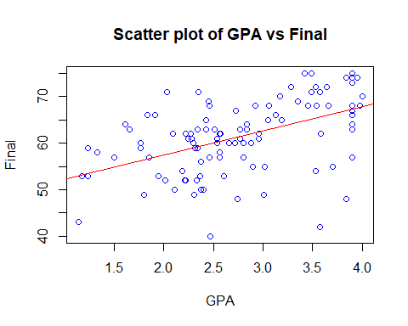

cor.test(grades$final, grades$quiz1)

##   
## Pearson's product-moment correlation  
##   
## data: grades$final and grades$quiz1  
## t = 6.428, df = 103, p-value = 4.094e-09  
## alternative hypothesis: true correlation is not equal to 0  
## 95 percent confidence interval:  
## 0.3826533 0.6591421  
## sample estimates:  
## cor   
## 0.5350754

plot(final~quiz1, data = grades, main= "Scatter plot of Quiz1 vs Final",col= 'blue', ylab= 'Fianal', xlab="Quiz1")  
abline(lm(grades$final~grades$quiz1), col="red")

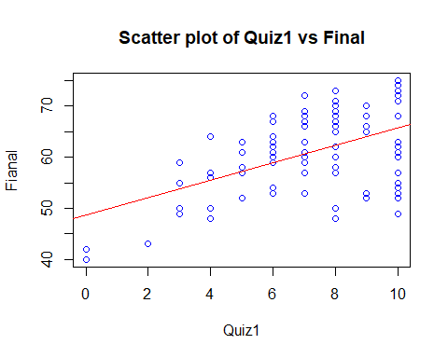

cor.test(grades$final, grades$quiz2)

##   
## Pearson's product-moment correlation  
##   
## data: grades$final and grades$quiz2  
## t = 6.7162, df = 103, p-value = 1.047e-09  
## alternative hypothesis: true correlation is not equal to 0  
## 95 percent confidence interval:  
## 0.4028080 0.6724089  
## sample estimates:  
## cor   
## 0.5518668

plot(final~quiz2, data = grades, main= "Scatter plot of Quiz2 vs Final",col= 'blue', ylab= 'Fianal', xlab="Quiz2")  
abline(lm(grades$final~grades$quiz2), col="red")

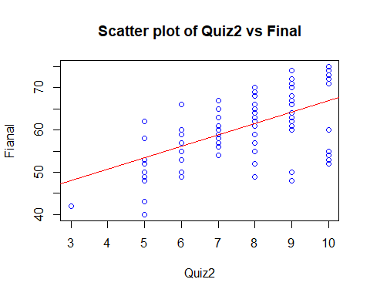

cor.test(grades$final, grades$quiz3)

##   
## Pearson's product-moment correlation  
##   
## data: grades$final and grades$quiz3  
## t = 6.8809, df = 103, p-value = 4.758e-10  
## alternative hypothesis: true correlation is not equal to 0  
## 95 percent confidence interval:  
## 0.4140461 0.6797318  
## sample estimates:  
## cor   
## 0.5611773

plot(final~quiz3, data = grades, main= "Scatter plot of Quiz3 vs Final",col= 'blue', ylab= 'Fianal', xlab="Quiz3")  
abline(lm(grades$final~grades$quiz3), col="red")

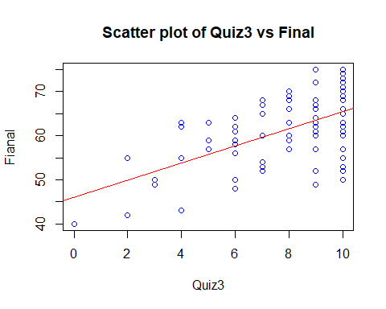

cor.test(grades$final, grades$quiz4)

##   
## Pearson's product-moment correlation  
##   
## data: grades$final and grades$quiz4  
## t = 5.6716, df = 103, p-value = 1.303e-07  
## alternative hypothesis: true correlation is not equal to 0  
## 95 percent confidence interval:  
## 0.3267180 0.6213986  
## sample estimates:  
## cor   
## 0.4878348

plot(final~quiz4, data = grades, main= "Scatter plot of Quiz4 vs Final",col= 'blue', ylab= 'Fianal', xlab="Quiz4")  
abline(lm(grades$final~grades$quiz4), col="red")

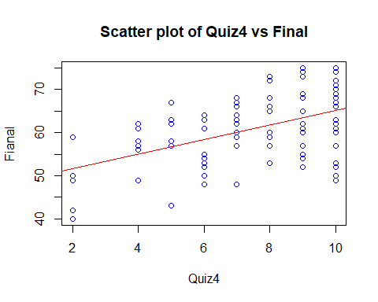

cor.test(grades$final, grades$quiz5)

##   
## Pearson's product-moment correlation  
##   
## data: grades$final and grades$quiz5  
## t = 5.4264, df = 103, p-value = 3.834e-07  
## alternative hypothesis: true correlation is not equal to 0  
## 95 percent confidence interval:  
## 0.3076485 0.6082107  
## sample estimates:  
## cor   
## 0.4715109

plot(final~quiz5, data = grades, main= "Scatter plot of Quiz5 vs Final",col= 'blue', ylab= 'Fianal', xlab="Quiz5")  
abline(lm(grades$final~grades$quiz5), col="red")

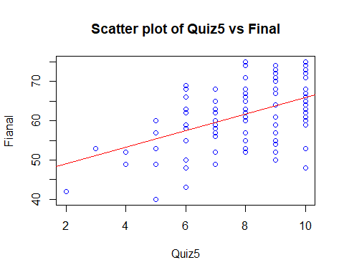

cor.test(grades$final, grades$total)

##   
## Pearson's product-moment correlation  
##   
## data: grades$final and grades$total  
## t = 19.054, df = 103, p-value < 2.2e-16  
## alternative hypothesis: true correlation is not equal to 0  
## 95 percent confidence interval:  
## 0.8316264 0.9188386  
## sample estimates:  
## cor   
## 0.8826091

plot(final~total, data = grades, main= "Scatter plot of Total vs Final",col= 'blue', ylab= 'Fianal', xlab="Total")  
abline(lm(grades$final~grades$total), col="red")

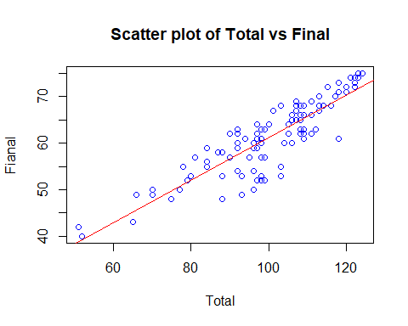

#After correlation test start with buliding regression models and validate  
model1<- lm(final ~ gpa+quiz1+quiz2+quiz3+quiz4+quiz5+total, data=grades)  
model1

##   
## Call:  
## lm(formula = final ~ gpa + quiz1 + quiz2 + quiz3 + quiz4 + quiz5 +   
## total, data = grades)  
##   
## Coefficients:  
## (Intercept) gpa quiz1 quiz2 quiz3   
## 2.2504 0.2851 -0.9128 -0.8394 -0.8627   
## quiz4 quiz5 total   
## -0.9338 -0.8095 0.9196

summary(model1)

##   
## Call:  
## lm(formula = final ~ gpa + quiz1 + quiz2 + quiz3 + quiz4 + quiz5 +   
## total, data = grades)  
##   
## Residuals:  
## Min 1Q Median 3Q Max   
## -9.2806 -0.2002 0.0674 0.3430 8.1334   
##   
## Coefficients:  
## Estimate Std. Error t value Pr(>|t|)   
## (Intercept) 2.25044 1.05481 2.133 0.0354 *   
## gpa 0.28514 0.19778 1.442 0.1526   
## quiz1 -0.91284 0.12206 -7.478 3.38e-11 ***  
## quiz2 -0.83941 0.14401 -5.829 7.30e-08 ***  
## quiz3 -0.86271 0.12707 -6.789 9.03e-10 ***  
## quiz4 -0.93377 0.11052 -8.449 2.95e-13 ***  
## quiz5 -0.80947 0.10964 -7.383 5.37e-11 ***  
## total 0.91960 0.02192 41.943 < 2e-16 ***  
## ---  
## Signif. codes: 0 '***' 0.001 '**' 0.01 '*' 0.05 '.' 0.1 ' ' 1  
##   
## Residual standard error: 1.34 on 97 degrees of freedom  
## Multiple R-squared: 0.9735, Adjusted R-squared: 0.9715   
## F-statistic: 508.3 on 7 and 97 DF, p-value: < 2.2e-16

#Lets check variance inflation factor and durbin watson statistics to check for inflation of r- square and auto correlation.  
vif(model1)

## gpa quiz1 quiz2 quiz3 quiz4 quiz5 total   
## 1.322065 5.312639 3.164871 4.982488 3.679254 2.170517 6.518202

durbinWatsonTest(model1)

## lag Autocorrelation D-W Statistic p-value  
## 1 -0.02699258 2.050631 0.812  
## Alternative hypothesis: rho != 0

#In Model1, variable GPA does not have significant slope with response variable, variance inflation factor results not allowing to build a model with total as one of the predictor. Lets build one more model by removing total alone.   
model2<- lm(final ~ gpa+quiz1+quiz2+quiz3+quiz4+quiz5, data=grades)  
model2

##   
## Call:  
## lm(formula = final ~ gpa + quiz1 + quiz2 + quiz3 + quiz4 + quiz5,   
## data = grades)  
##   
## Coefficients:  
## (Intercept) gpa quiz1 quiz2 quiz3   
## 32.8658 3.6271 0.2986 0.8004 0.9063   
## quiz4 quiz5   
## -0.1428 0.4823

summary(model2)

##   
## Call:  
## lm(formula = final ~ gpa + quiz1 + quiz2 + quiz3 + quiz4 + quiz5,   
## data = grades)  
##   
## Residuals:  
## Min 1Q Median 3Q Max   
## -13.6580 -2.7187 0.7985 3.9664 11.4979   
##   
## Coefficients:  
## Estimate Std. Error t value Pr(>|t|)   
## (Intercept) 32.8658 3.3141 9.917 < 2e-16 ***  
## gpa 3.6271 0.7879 4.604 1.25e-05 ***  
## quiz1 0.2986 0.5162 0.578 0.5643   
## quiz2 0.8004 0.6032 1.327 0.1876   
## quiz3 0.9063 0.5217 1.737 0.0855 .   
## quiz4 -0.1428 0.4739 -0.301 0.7638   
## quiz5 0.4823 0.4580 1.053 0.2948   
## ---  
## Signif. codes: 0 '***' 0.001 '**' 0.01 '*' 0.05 '.' 0.1 ' ' 1  
##   
## Residual standard error: 5.831 on 98 degrees of freedom  
## Multiple R-squared: 0.4922, Adjusted R-squared: 0.4611   
## F-statistic: 15.83 on 6 and 98 DF, p-value: 1.224e-12

vif(model2)

## gpa quiz1 quiz2 quiz3 quiz4 quiz5   
## 1.107509 5.015198 2.931613 4.433567 3.572136 1.999252

durbinWatsonTest(model2)

## lag Autocorrelation D-W Statistic p-value  
## 1 -0.1175758 2.224256 0.246  
## Alternative hypothesis: rho != 0

#From Model2, VIF result it concluded that quiz1 is increasing corelation artificially, hence it will be removed from model an new model is constructed as follows  
model3<- lm(final ~ gpa+quiz2+quiz3+quiz4+quiz5, data=grades)  
model3

##   
## Call:  
## lm(formula = final ~ gpa + quiz2 + quiz3 + quiz4 + quiz5, data = grades)  
##   
## Coefficients:  
## (Intercept) gpa quiz2 quiz3 quiz4   
## 32.49410 3.62466 0.82825 1.06375 -0.02019   
## quiz5   
## 0.50431

summary(model3)

##   
## Call:  
## lm(formula = final ~ gpa + quiz2 + quiz3 + quiz4 + quiz5, data = grades)  
##   
## Residuals:  
## Min 1Q Median 3Q Max   
## -13.5494 -2.7210 0.5787 4.0927 11.5517   
##   
## Coefficients:  
## Estimate Std. Error t value Pr(>|t|)   
## (Intercept) 32.49410 3.24023 10.028 < 2e-16 ***  
## gpa 3.62466 0.78519 4.616 1.17e-05 ***  
## quiz2 0.82825 0.59928 1.382 0.1701   
## quiz3 1.06375 0.44360 2.398 0.0184 *   
## quiz4 -0.02019 0.42244 -0.048 0.9620   
## quiz5 0.50431 0.45486 1.109 0.2702   
## ---  
## Signif. codes: 0 '***' 0.001 '**' 0.01 '*' 0.05 '.' 0.1 ' ' 1  
##   
## Residual standard error: 5.812 on 99 degrees of freedom  
## Multiple R-squared: 0.4904, Adjusted R-squared: 0.4647   
## F-statistic: 19.06 on 5 and 99 DF, p-value: 3.089e-13

vif(model3)

## gpa quiz2 quiz3 quiz4 quiz5   
## 1.107478 2.912966 3.227419 2.857258 1.985498

durbinWatsonTest(model3)

## lag Autocorrelation D-W Statistic p-value  
## 1 -0.1288976 2.247614 0.264  
## Alternative hypothesis: rho != 0

#From model3 summary and VIF Out put, it was decided that though no inflators in model3.variables quiz2, quiz4 and quiz5 does not have significant pvalue they were removed and model as follows  
model4<- lm(final ~ gpa+quiz3, data=grades)  
model4

##   
## Call:  
## lm(formula = final ~ gpa + quiz3, data = grades)  
##   
## Coefficients:  
## (Intercept) gpa quiz3   
## 37.541 3.993 1.609

summary(model4)

##   
## Call:  
## lm(formula = final ~ gpa + quiz3, data = grades)  
##   
## Residuals:  
## Min 1Q Median 3Q Max   
## -14.5260 -3.2000 -0.0803 4.7388 12.3955   
##   
## Coefficients:  
## Estimate Std. Error t value Pr(>|t|)   
## (Intercept) 37.5415 2.6802 14.007 < 2e-16 ***  
## gpa 3.9926 0.7850 5.086 1.67e-06 ***  
## quiz3 1.6088 0.2598 6.193 1.26e-08 ***  
## ---  
## Signif. codes: 0 '***' 0.001 '**' 0.01 '*' 0.05 '.' 0.1 ' ' 1  
##   
## Residual standard error: 5.929 on 102 degrees of freedom  
## Multiple R-squared: 0.4535, Adjusted R-squared: 0.4428   
## F-statistic: 42.32 on 2 and 102 DF, p-value: 4.133e-14

vif(model4)

## gpa quiz3   
## 1.06341 1.06341

durbinWatsonTest(model4)

## lag Autocorrelation D-W Statistic p-value  
## 1 -0.09929107 2.194562 0.304  
## Alternative hypothesis: rho != 0

#from model4 out put and vif, both predictors can be used for regression, lets plot final vs predictors of GPA and quiz3  
plot(final~gpa+quiz3, data = grades)

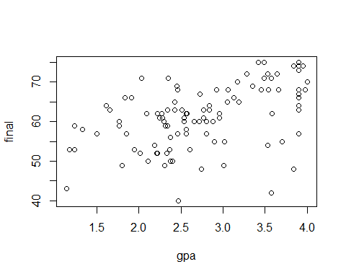

abline(lm(grades$final~grades$gpa+grades$quiz3), col="red")

## Warning in abline(lm(grades$final ~ grades$gpa + grades$quiz3), col =  
## "red"): only using the first two of 3 regression coefficients

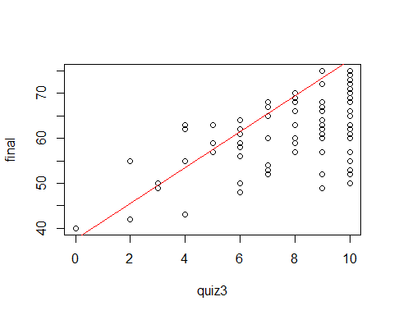

scatterplot(final~quiz3|gender, data=grades)

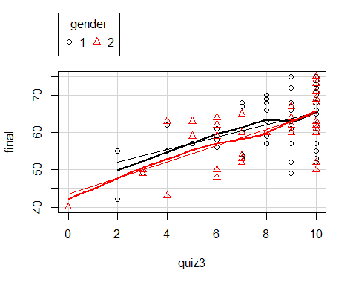

scatterplot(final~gpa|gender, data=grades)

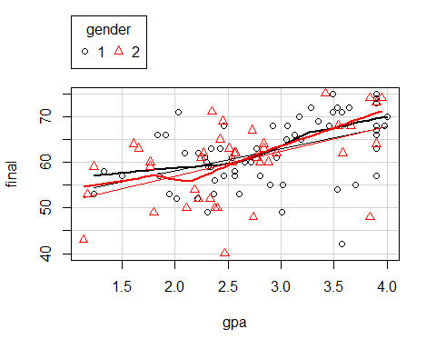

scatterplot(final~quiz3|section, data=grades)

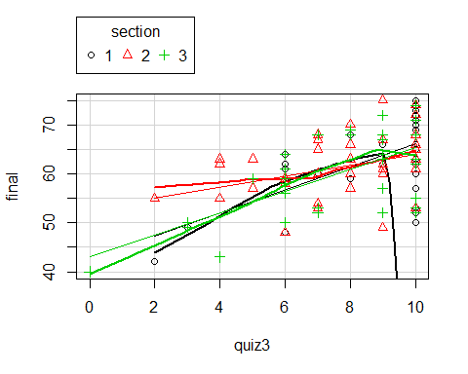

scatterplot(final~gpa|section, data=grades)

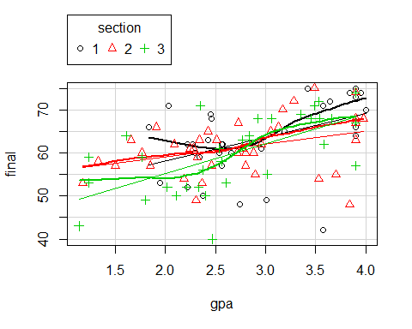

scatterplot(final~quiz3|ethnicity, data=grades)

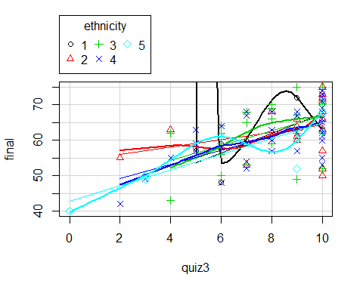

scatterplot(final~gpa|ethnicity, data=grades)

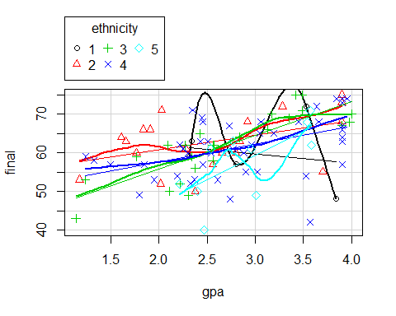

#visualize association of predictors and response variable.  
pairs(~final+gpa+quiz1+quiz2+quiz3+quiz4+quiz5+total, data=grades, main= "scatter plot matrix")

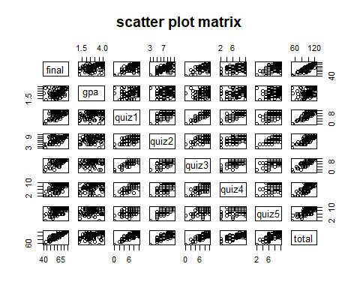

#Model4 is having R-squred value less when comapred with model3.. so, model3 will be selected as final model  
#4.How do you interpret significance value of F-statistics? Mention in 4 lines and show R Output. [Fitness of model]  
anova(model3)

## Analysis of Variance Table  
##   
## Response: final  
## Df Sum Sq Mean Sq F value Pr(>F)   
## gpa 1 1627.8 1627.81 48.1944 4.077e-10 ***  
## quiz2 1 1226.1 1226.12 36.3016 2.898e-08 ***  
## quiz3 1 322.7 322.75 9.5555 0.002589 **   
## quiz4 1 0.2 0.18 0.0054 0.941762   
## quiz5 1 41.5 41.52 1.2293 0.270235   
## Residuals 99 3343.8 33.78   
## ---  
## Signif. codes: 0 '***' 0.001 '**' 0.01 '*' 0.05 '.' 0.1 ' ' 1

anova(model4)

## Analysis of Variance Table  
##   
## Response: final  
## Df Sum Sq Mean Sq F value Pr(>F)   
## gpa 1 1627.8 1627.81 46.300 7.096e-10 ***  
## quiz3 1 1348.3 1348.28 38.349 1.255e-08 ***  
## Residuals 102 3586.1 35.16   
## ---  
## Signif. codes: 0 '***' 0.001 '**' 0.01 '*' 0.05 '.' 0.1 ' ' 1

#From anova test p value it can conclude that quiz2, quiz4 and quiz5 are not having significant slope with response variable fianl So, lets Check durbin watson statistic test to check auto corrrlation among variables.  
durbinWatsonTest(model3)

## lag Autocorrelation D-W Statistic p-value  
## 1 -0.1288976 2.247614 0.174  
## Alternative hypothesis: rho != 0

durbinWatsonTest(model4)

## lag Autocorrelation D-W Statistic p-value  
## 1 -0.09929107 2.194562 0.304  
## Alternative hypothesis: rho != 0

plot(model4)

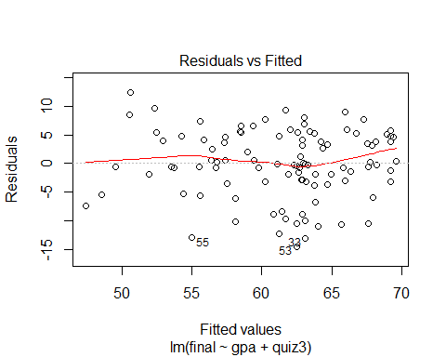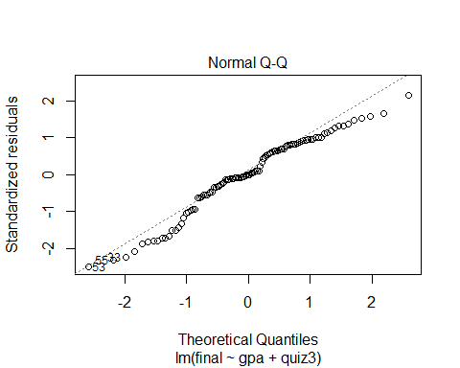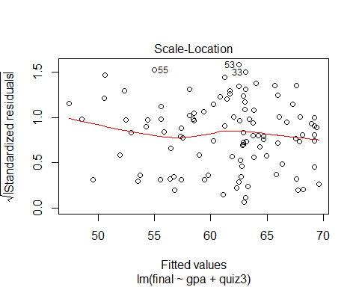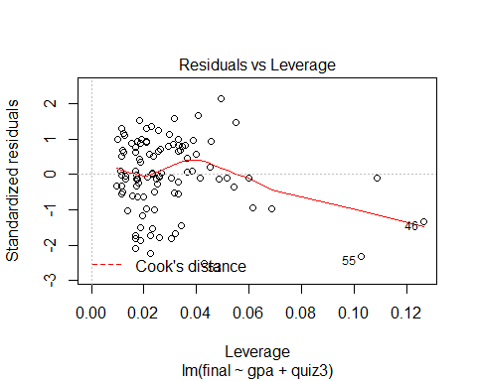

#9. Test the assumption of Normality and interpret your findings. [hint: histogram of residuals/errors]  
#Show histogram and interpret in maximum 3 lines.   
#Lets find error/residual term of model3 as below  
residual<-residuals(model4)  
residual

## 1 2 3 4 5   
## -0.51437366 -3.54694323 -3.23375140 3.30622554 6.63289284   
## 6 7 8 9 10   
## 4.79925345 -1.96854482 3.11682569 4.59962129 9.04503165   
## 11 12 13 14 15   
## 2.54280767 7.98785032 5.58858601 -0.55533632 -6.10591327   
## 16 17 18 19 20   
## 3.66442618 12.39554117 -10.13410245 7.39299999 -3.77075188   
## 21 22 23 24 25   
## -0.53186180 -1.20074655 -8.84438513 7.76624860 -5.52828439   
## 26 27 28 29 30   
## 9.67870462 0.02777675 9.26549612 0.23513348 -1.61288537   
## 31 32 33 34 35   
## -0.12387015 -10.68722058 -13.13192897 4.74461330 -8.89708504   
## 36 37 38 39 40   
## -11.05023690 -3.20004458 0.57651449 -0.08026529 5.03881204   
## 41 42 43 44 45   
## -0.69675092 -0.75463422 6.93147197 7.71572216 -2.88063313   
## 46 47 48 49 50   
## -7.40332171 5.49552438 -2.98315752 4.79925345 1.98751606   
## 51 52 53 54 55   
## 5.79925345 5.21279621 -14.52600990 5.42232641 -13.01281820   
## 56 57 58 59 60   
## -0.80699988 -0.75393225 4.73876140 3.83734067 0.58457332   
## 61 62 63 64 65   
## 8.46365678 0.59918602 -0.59195203 -5.92310074 5.55120076   
## 66 67 68 69 70   
## 4.12996688 -0.28173666 -1.83886748 3.09117770 -10.59195203   
## 71 72 73 74 75   
## -0.69273823 6.49482241 -1.91066152 -1.95022024 -5.38573255   
## 76 77 78 79 80   
## 3.79925345 0.39998914 -0.49310607 4.58457332 -8.41509242   
## 81 82 83 84 85   
## -3.20074655 0.23660498 -0.24251219 -6.85060474 5.92963276   
## 86 87 88 89 90   
## 3.79925345 -12.24364944 -3.68905980 5.46663324 4.02814446   
## 91 92 93 94 95   
## 3.43623714 -10.49310607 5.27469220 4.07944044 -9.69457744   
## 96 97 98 99 100   
## 5.88532593 2.62563700 -2.81251752 -10.09200254 -1.36596992   
## 101 102 103 104 105   
## 1.23443151 -0.55463435 -5.61873727 -0.33156113 3.76186820

summary(residual)

## Min. 1st Qu. Median Mean 3rd Qu. Max.   
## -14.52601 -3.20004 -0.08027 0.00000 4.73876 12.39554

hist(residual, col="red", main = "Histogram of Mode4 errors", xlab = "Error", ylab = "Frequency")

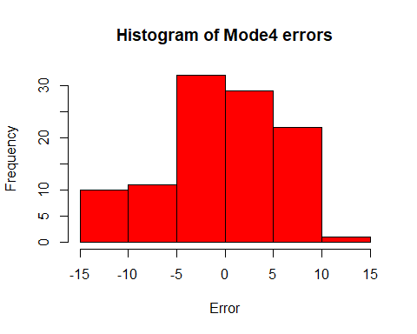

boxplot(residual, col="red", horizontal = T)

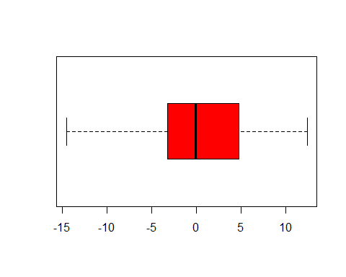

#10. Test the assumption of Independent of observations and interpret in maximum 3 lines [hint: draw scatter plot between residuals/errors (y-axis) and observation numbers (x-axis)]  
grades$residual=NULL  
grades$residual=residual  
obs_no<-c(1:105)  
grades$obs_no=NULL  
grades$obs_no=obs_no  
grades

## Sr_No id lastname firstname gender ethnicity year lowup section  
## 1 1 106484 VILLARRUZ ALFRED 2 2 2 1 2  
## 2 2 108642 VALAZQUEZ SCOTT 2 4 3 2 2  
## 3 3 127285 GALVEZ JACKIE 1 4 4 2 2  
## 4 4 132931 OSBORNE ANN 1 3 2 1 2  
## 5 5 140219 GUADIZ VALERIE 1 2 4 2 1  
## 6 6 142630 RANGIFO TANIECE 1 4 3 2 3  
## 7 7 153964 TOMOSAWA DANIEL 2 2 3 2 3  
## 8 8 154441 LIAN JENNY 1 5 2 1 1  
## 9 9 157147 BAKKEN KREG 2 4 3 2 1  
## 10 10 164605 LANGFORD DAWN 1 3 3 2 2  
## 11 11 164842 VALENZUELA NANCY 1 1 4 2 2  
## 12 12 167664 SWARM MARK 2 4 3 2 3  
## 13 13 175325 KHOURY DENNIS 2 4 3 2 1  
## 14 14 192627 MISCHKE ELAINE 1 4 1 1 2  
## 15 15 211239 AUSTIN DERRICK 2 4 3 2 3  
## 16 16 219593 POTTER MICKEY 1 5 3 2 3  
## 17 17 237983 LEE JONATHAN 2 2 4 2 2  
## 18 18 245473 DAYES ROBERT 2 4 3 2 1  
## 19 19 249586 STOLL GLENDON 2 4 3 2 2  
## 20 20 260983 CUSTER JAMES 2 4 4 2 1  
## 21 21 273611 WU VIDYUTH 1 2 2 1 2  
## 22 22 280440 CHANG RENE 1 2 3 2 2  
## 23 23 287617 CUMMINGS DAVENA 1 5 3 2 3  
## 24 24 289652 BRADLEY SHANNON 1 4 3 2 1  
## 25 25 302400 JONES ROBERT 2 3 4 2 3  
## 26 26 307894 TORRENCE GWEN 1 3 2 1 2  
## 27 27 337908 UYEYAMA VICTORINE 1 1 3 2 2  
## 28 28 354601 CARPIO MARY 1 2 2 1 1  
## 29 29 378446 SAUNDERS TAMARA 1 1 2 1 2  
## 30 30 380157 LUTZ WILLIAM 2 4 3 2 2  
## 31 31 390203 SHIMA MIHAELA 1 2 3 2 2  
## 32 32 392464 DOMINGO MONIKA 1 4 3 2 3  
## 33 33 414775 RATANA JASON 2 2 3 2 1  
## 34 34 417003 EVANGELIST NIKKI 1 2 3 2 2  
## 35 35 419891 DE CANIO PAULA 1 4 3 2 2  
## 36 36 420327 BADGER SUZANNA 1 4 3 2 3  
## 37 37 434571 SURI MATHEW 2 2 3 2 2  
## 38 38 436413 PANG SUZANNE 1 2 3 2 1  
## 39 39 447659 GALANVILLE DANA 1 5 4 2 3  
## 40 40 463276 HANSEN TIM 2 4 3 2 1  
## 41 41 466407 PICKERING HEIDI 1 3 3 2 3  
## 42 42 467806 DEVERS GAIL 1 3 3 2 1  
## 43 43 473303 PARK SANDRA 1 3 4 2 2  
## 44 44 479547 LANGFORD BLAIR 2 3 3 2 1  
## 45 45 490016 STEPHEN LIZA 1 5 3 2 2  
## 46 46 498900 HUANG JOE 2 5 3 2 3  
## 47 47 506467 SCARBROUGH CYNTHE 1 4 3 2 2  
## 48 48 515586 FIALLOS LAUREL 1 4 2 1 2  
## 49 49 519444 RATHBUN DAWNE 1 4 4 2 2  
## 50 50 546022 HAMIDI KIMBERLY 1 5 3 2 1  
## 51 51 553919 KWON SHELLY 1 2 3 2 1  
## 52 52 554809 JONES LISA 1 3 3 2 3  
## 53 53 574170 HURRIA WAYNE 2 1 2 1 2  
## 54 54 576008 BULMERKA HUSIBA 1 4 4 2 3  
## 55 55 576141 MISHALANY LUCY 1 4 3 2 1  
## 56 56 594463 CRUZADO MARITESS 1 4 4 2 2  
## 57 57 595177 WILLIAMS OLIMPIA 1 3 3 2 3  
## 58 58 615115 VASENIUS RUSS 2 3 3 2 3  
## 59 59 616095 SPRINGER ANNELIES 1 4 3 2 1  
## 60 60 623857 CORTEZ VIKKI 1 3 4 2 3  
## 61 61 664653 KHAN JOHN 2 4 3 2 3  
## 62 62 681855 GRISWOLD TAMMY 1 4 3 2 2  
## 63 63 700978 WEBSTER DEANNA 1 3 2 1 3  
## 64 64 703740 SUNYA DALE 2 5 3 2 3  
## 65 65 721311 SONG LOIS 2 2 3 2 3  
## 66 66 725987 BATILLER FRED 2 2 2 1 2  
## 67 67 737728 BELTRAN JIM 2 3 3 2 1  
## 68 68 755724 LANGFORD TREVOR 2 4 3 2 2  
## 69 69 756097 KURSEE JACKIE 1 3 3 2 2  
## 70 70 762308 GOUW BONNIE 1 4 2 1 3  
## 71 71 762813 DAEL IVAN 2 3 2 1 1  
## 72 72 765360 ROBINSON ERIC 2 3 3 2 2  
## 73 73 768995 DUMITRESCU STACY 2 4 4 2 2  
## 74 74 777683 ANDERSON ERIC 2 5 4 2 3  
## 75 75 779481 AHGHEL BRENDA 1 5 3 2 1  
## 76 76 780028 ROBINSON CLAYTON 2 4 3 2 1  
## 77 77 781676 WATKINS YVONNE 1 3 4 2 1  
## 78 78 798931 ZUILL RENAE 1 4 3 2 1  
## 79 79 807963 LEWIS CARL 2 3 2 1 1  
## 80 80 818528 CARRINGTON JYLL 1 4 3 2 1  
## 81 81 822485 VALENZUELA KATHRYN 1 4 1 1 1  
## 82 82 843472 PRADO DON 2 5 3 2 3  
## 83 83 870810 REYNO NICHOLAS 2 4 3 2 3  
## 84 84 896972 HUANG MIRNA 1 2 3 2 1  
## 85 85 897606 GENOBAGA JACQUELINE 1 2 3 2 3  
## 86 86 898766 RAO DAWN 1 2 3 2 1  
## 87 87 899529 HAWKINS CARHERINE 1 3 4 2 2  
## 88 88 900485 COCHRAN STACY 2 4 3 2 2  
## 89 89 905109 JENKINS ERIC 2 3 2 1 3  
## 90 90 908754 MARQUEZ CHYRELLE 1 4 1 1 2  
## 91 91 911355 LESKO LETICIA 1 3 2 1 3  
## 92 92 915457 SHEARER LUCIO 2 3 3 2 1  
## 93 93 920656 LIAO MICHELLE 1 2 2 1 2  
## 94 94 921297 KINZER RICHARD 2 4 3 2 2  
## 95 95 938666 SUAREZ-TAN KHANH 1 2 3 2 3  
## 96 96 938881 YEO DENISE 1 1 3 2 3  
## 97 97 944702 LEDESMA MARTINE 1 4 3 2 2  
## 98 98 958384 RONCO SHERRY 1 4 2 1 1  
## 99 99 972678 KAHRS JANN 1 4 4 2 2  
## 100 100 973427 ROSS MARIA 1 4 4 2 1  
## 101 101 978889 ZIMCHEK ARMANDO 2 4 4 2 1  
## 102 102 979028 NEUHARTH JIM 2 4 3 2 3  
## 103 103 983522 SLOAT AARON 2 3 3 2 3  
## 104 104 985700 CHA LILY 1 4 2 1 1  
## 105 105 988808 MCCONAHA CORA 1 4 3 2 3  
## gpa extrc review quiz1 quiz2 quiz3 quiz4 quiz5 final total percent  
## 1 1.18 1 2 6 5 7 6 3 53 80 64  
## 2 2.19 2 1 10 10 7 6 9 54 96 77  
## 3 2.46 2 2 10 7 8 9 7 57 98 78  
## 4 3.98 1 1 7 8 7 7 6 68 103 82  
## 5 1.84 1 1 7 8 9 8 10 66 108 86  
## 6 3.90 1 2 10 10 10 9 9 74 122 98  
## 7 2.84 2 1 10 9 10 10 10 63 112 90  
## 8 3.57 1 2 10 9 10 10 10 71 120 96  
## 9 3.95 2 2 10 10 10 10 9 74 123 98  
## 10 3.49 2 1 10 10 9 10 10 75 124 99  
## 11 2.32 1 1 7 8 6 7 10 59 97 78  
## 12 2.35 1 2 8 10 10 10 9 71 118 94  
## 13 2.45 1 1 8 8 10 10 6 69 111 89  
## 14 2.90 1 1 3 8 4 6 8 55 84 67  
## 15 2.33 1 2 5 5 7 6 4 52 79 63  
## 16 2.54 1 2 5 8 6 4 10 61 94 75  
## 17 1.66 2 2 5 7 4 7 6 63 92 74  
## 18 2.74 1 1 8 9 6 7 10 48 88 70  
## 19 2.51 1 1 5 9 5 6 10 63 98 78  
## 20 2.54 1 1 10 9 10 10 7 60 106 85  
## 21 3.70 1 2 3 6 2 6 6 55 78 62  
## 22 3.90 1 2 10 8 10 10 8 68 114 91  
## 23 2.21 1 2 9 10 9 9 9 52 98 78  
## 24 2.46 1 2 6 9 8 9 9 68 109 87  
## 25 1.14 1 2 2 5 4 5 6 43 65 52  
## 26 2.09 2 2 6 5 4 7 6 62 90 72  
## 27 2.34 2 1 10 8 10 10 7 63 108 86  
## 28 2.03 1 2 10 10 10 10 9 71 120 96  
## 29 2.80 1 2 4 6 5 4 5 57 81 65  
## 30 2.25 2 2 10 9 10 10 8 61 118 86  
## 31 2.28 1 2 6 7 9 6 8 61 97 78  
## 32 3.02 2 1 10 10 10 9 9 55 103 82  
## 33 2.38 1 2 8 9 10 10 9 50 96 77  
## 34 1.91 1 2 9 8 10 10 6 66 109 87  
## 35 3.53 1 2 6 7 7 9 9 54 92 74  
## 36 2.61 1 2 10 10 10 10 10 53 103 82  
## 37 2.80 1 1 7 6 9 8 8 60 98 78  
## 38 2.66 1 2 8 6 7 8 7 60 96 77  
## 39 2.77 1 1 6 8 9 5 8 63 99 79  
## 40 3.84 2 2 10 10 10 9 10 74 123 98  
## 41 2.38 1 1 4 7 6 4 7 56 84 67  
## 42 2.34 1 1 7 6 8 7 9 59 96 77  
## 43 3.17 1 2 8 8 8 10 9 70 113 90  
## 44 3.42 2 2 10 10 10 9 10 75 124 99  
## 45 2.72 1 2 8 9 9 8 10 60 104 83  
## 46 2.47 1 1 0 5 0 2 5 40 52 42  
## 47 1.33 1 2 8 5 6 4 7 58 88 70  
## 48 3.90 1 1 7 8 8 6 6 63 98 78  
## 49 3.90 1 1 10 9 10 10 8 74 121 97  
## 50 2.96 1 1 7 7 6 9 8 61 98 78  
## 51 3.90 2 2 10 10 10 10 8 75 123 98  
## 52 3.35 1 1 7 8 8 9 6 69 107 86  
## 53 3.84 1 1 4 5 6 6 6 48 75 60  
## 54 3.45 2 1 10 8 7 9 7 68 109 87  
## 55 3.57 1 2 0 3 2 2 2 42 51 41  
## 56 3.05 1 2 9 8 10 8 8 65 108 86  
## 57 1.24 1 1 7 6 7 10 5 53 88 70  
## 58 1.77 1 2 6 7 6 8 6 59 92 74  
## 59 3.64 1 2 10 10 10 10 10 72 122 98  
## 60 2.56 1 2 5 7 6 5 6 58 87 70  
## 61 1.24 1 2 3 8 5 2 7 59 84 67  
## 62 1.50 1 2 5 7 8 5 8 57 90 72  
## 63 3.90 1 2 8 9 9 10 10 67 113 90  
## 64 3.58 1 2 10 9 10 10 7 62 108 86  
## 65 1.61 1 1 6 9 9 7 10 64 105 84  
## 66 1.77 1 2 6 7 7 7 5 60 92 74  
## 67 2.57 1 1 6 8 9 5 7 62 97 78  
## 68 2.96 1 2 8 9 9 9 8 62 105 84  
## 69 3.13 1 2 9 6 8 7 10 66 106 85  
## 70 3.90 1 2 8 7 9 10 8 57 99 79  
## 71 2.27 2 2 10 9 10 10 10 62 111 89  
## 72 2.43 1 2 8 8 7 8 10 65 106 85  
## 73 2.88 1 1 7 10 8 9 10 60 104 83  
## 74 2.40 1 1 3 6 3 2 6 50 70 56  
## 75 3.01 1 2 3 5 3 2 4 49 66 53  
## 76 3.90 1 2 10 10 10 9 10 73 122 98  
## 77 4.00 1 2 9 9 10 10 9 70 117 94  
## 78 2.22 2 2 10 9 10 10 8 62 109 87  
## 79 2.56 2 1 8 5 6 4 7 62 92 74  
## 80 1.95 1 2 9 10 10 8 8 53 98 78  
## 81 3.90 1 2 8 9 10 10 8 66 111 89  
## 82 3.54 1 2 9 9 10 8 9 68 113 90  
## 83 3.66 2 1 10 8 10 10 10 68 116 93  
## 84 2.56 1 1 7 6 10 8 7 57 95 76  
## 85 2.92 1 2 8 9 8 8 7 68 108 86  
## 86 3.90 1 2 8 10 10 8 9 73 118 94  
## 87 2.31 1 1 10 8 9 10 7 49 93 74  
## 88 2.77 2 2 10 9 10 10 9 61 109 87  
## 89 2.84 1 1 6 8 6 6 10 64 100 80  
## 90 1.85 1 2 4 8 5 7 9 57 90 72  
## 91 3.49 1 2 10 9 10 10 8 71 118 94  
## 92 2.22 1 2 10 10 10 9 8 52 99 79  
## 93 3.28 2 2 10 9 10 10 9 72 120 96  
## 94 2.73 1 2 7 9 9 7 8 67 107 86  
## 95 2.02 2 2 10 8 10 10 7 52 97 78  
## 96 3.53 1 2 7 10 9 8 9 72 115 92  
## 97 3.90 1 2 6 7 7 5 9 67 101 81  
## 98 2.30 1 2 10 9 10 10 7 60 106 85  
## 99 2.37 1 2 10 10 10 10 10 53 93 74  
## 100 3.19 1 2 9 7 10 9 7 65 107 86  
## 101 3.90 1 2 4 8 6 6 9 64 97 78  
## 102 1.80 1 2 3 6 3 4 5 49 70 56  
## 103 2.11 1 1 4 5 6 6 6 50 77 62  
## 104 2.43 2 2 10 9 10 10 7 63 109 87  
## 105 3.06 1 2 7 8 9 8 7 68 107 86  
## grade passfail residual obs_no  
## 1 D P -0.51437366 1  
## 2 C P -3.54694323 2  
## 3 C P -3.23375140 3  
## 4 B P 3.30622554 4  
## 5 B P 6.63289284 5  
## 6 A P 4.79925345 6  
## 7 A P -1.96854482 7  
## 8 A P 3.11682569 8  
## 9 A P 4.59962129 9  
## 10 A P 9.04503165 10  
## 11 C P 2.54280767 11  
## 12 A P 7.98785032 12  
## 13 B P 5.58858601 13  
## 14 D P -0.55533632 14  
## 15 D P -6.10591327 15  
## 16 C P 3.66442618 16  
## 17 C P 12.39554117 17  
## 18 C P -10.13410245 18  
## 19 C P 7.39299999 19  
## 20 B P -3.77075188 20  
## 21 D P -0.53186180 21  
## 22 A P -1.20074655 22  
## 23 C P -8.84438513 23  
## 24 B P 7.76624860 24  
## 25 F F -5.52828439 25  
## 26 C P 9.67870462 26  
## 27 B P 0.02777675 27  
## 28 A P 9.26549612 28  
## 29 D P 0.23513348 29  
## 30 B P -1.61288537 30  
## 31 C P -0.12387015 31  
## 32 B P -10.68722058 32  
## 33 C P -13.13192897 33  
## 34 B P 4.74461330 34  
## 35 C P -8.89708504 35  
## 36 B P -11.05023690 36  
## 37 C P -3.20004458 37  
## 38 C P 0.57651449 38  
## 39 C P -0.08026529 39  
## 40 A P 5.03881204 40  
## 41 D P -0.69675092 41  
## 42 C P -0.75463422 42  
## 43 A P 6.93147197 43  
## 44 A P 7.71572216 44  
## 45 B P -2.88063313 45  
## 46 F F -7.40332171 46  
## 47 C P 5.49552438 47  
## 48 C P -2.98315752 48  
## 49 A P 4.79925345 49  
## 50 C P 1.98751606 50  
## 51 A P 5.79925345 51  
## 52 B P 5.21279621 52  
## 53 D P -14.52600990 53  
## 54 B P 5.42232641 54  
## 55 F F -13.01281820 55  
## 56 B P -0.80699988 56  
## 57 C P -0.75393225 57  
## 58 C P 4.73876140 58  
## 59 A P 3.83734067 59  
## 60 C P 0.58457332 60  
## 61 D P 8.46365678 61  
## 62 C P 0.59918602 62  
## 63 A P -0.59195203 63  
## 64 B P -5.92310074 64  
## 65 B P 5.55120076 65  
## 66 C P 4.12996688 66  
## 67 C P -0.28173666 67  
## 68 B P -1.83886748 68  
## 69 B P 3.09117770 69  
## 70 C P -10.59195203 70  
## 71 B P -0.69273823 71  
## 72 B P 6.49482241 72  
## 73 B P -1.91066152 73  
## 74 F F -1.95022024 74  
## 75 F F -5.38573255 75  
## 76 A P 3.79925345 76  
## 77 A P 0.39998914 77  
## 78 B P -0.49310607 78  
## 79 C P 4.58457332 79  
## 80 C P -8.41509242 80  
## 81 B P -3.20074655 81  
## 82 A O 0.23660498 82  
## 83 A P -0.24251219 83  
## 84 C P -6.85060474 84  
## 85 B P 5.92963276 85  
## 86 A P 3.79925345 86  
## 87 C P -12.24364944 87  
## 88 B P -3.68905980 88  
## 89 B P 5.46663324 89  
## 90 C P 4.02814446 90  
## 91 A P 3.43623714 91  
## 92 C P -10.49310607 92  
## 93 A P 5.27469220 93  
## 94 B P 4.07944044 94  
## 95 C P -9.69457744 95  
## 96 A P 5.88532593 96  
## 97 B P 2.62563700 97  
## 98 B P -2.81251752 98  
## 99 C P -10.09200254 99  
## 100 B P -1.36596992 100  
## 101 C P 1.23443151 101  
## 102 F F -0.55463435 102  
## 103 D P -5.61873727 103  
## 104 B P -0.33156113 104  
## 105 B P 3.76186820 105

#lets plot independent obseration numbers vs error   
plot(grades$obs_no, grades$residual, main="Independence of Residuals")  
abline(h = 0, col = "blue", lwd=2)

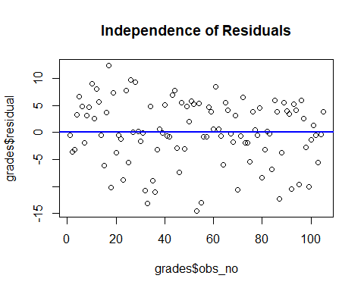

#11. Test the assumption of linear relationship and interpret in maximum 3 lines for each predictor [hint: draw scatter plot between response variable, final (y-axis) and predictor/s (x-axis). If more than one predictor is used in model then more scatter plots would be required]  
plot(grades$gpa, grades$final)  
abline(lm(grades$final~grades$gpa), col="red")

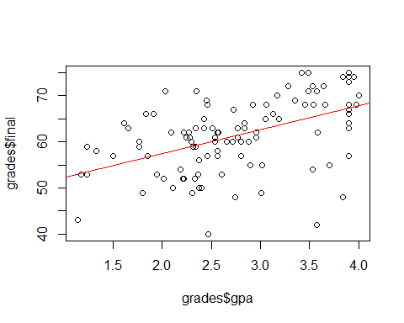

plot(grades$quiz3, grades$final)  
abline(lm(grades$final~grades$quiz3), col="red")

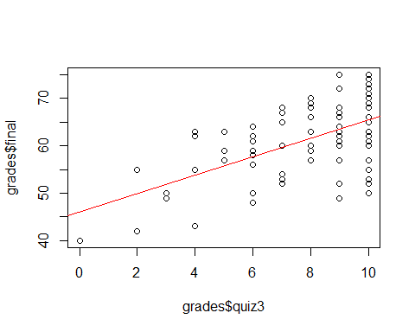

plot(grades$final, grades$residual)  
abline(h = 0, col = "red", lwd=2)

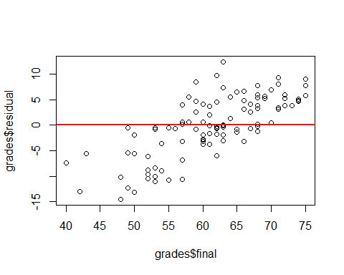

#12. Test the assumption of Constant Error Variance and interpret in maximum 3 lines [hint: draw scatter plot between residuals/errors (y-axis) and predicted values (x-axis)]  
pred<-predict(model4)  
grades$pred<-NULL  
grades$pred<-pred  
grades

## Sr_No id lastname firstname gender ethnicity year lowup section  
## 1 1 106484 VILLARRUZ ALFRED 2 2 2 1 2  
## 2 2 108642 VALAZQUEZ SCOTT 2 4 3 2 2  
## 3 3 127285 GALVEZ JACKIE 1 4 4 2 2  
## 4 4 132931 OSBORNE ANN 1 3 2 1 2  
## 5 5 140219 GUADIZ VALERIE 1 2 4 2 1  
## 6 6 142630 RANGIFO TANIECE 1 4 3 2 3  
## 7 7 153964 TOMOSAWA DANIEL 2 2 3 2 3  
## 8 8 154441 LIAN JENNY 1 5 2 1 1  
## 9 9 157147 BAKKEN KREG 2 4 3 2 1  
## 10 10 164605 LANGFORD DAWN 1 3 3 2 2  
## 11 11 164842 VALENZUELA NANCY 1 1 4 2 2  
## 12 12 167664 SWARM MARK 2 4 3 2 3  
## 13 13 175325 KHOURY DENNIS 2 4 3 2 1  
## 14 14 192627 MISCHKE ELAINE 1 4 1 1 2  
## 15 15 211239 AUSTIN DERRICK 2 4 3 2 3  
## 16 16 219593 POTTER MICKEY 1 5 3 2 3  
## 17 17 237983 LEE JONATHAN 2 2 4 2 2  
## 18 18 245473 DAYES ROBERT 2 4 3 2 1  
## 19 19 249586 STOLL GLENDON 2 4 3 2 2  
## 20 20 260983 CUSTER JAMES 2 4 4 2 1  
## 21 21 273611 WU VIDYUTH 1 2 2 1 2  
## 22 22 280440 CHANG RENE 1 2 3 2 2  
## 23 23 287617 CUMMINGS DAVENA 1 5 3 2 3  
## 24 24 289652 BRADLEY SHANNON 1 4 3 2 1  
## 25 25 302400 JONES ROBERT 2 3 4 2 3  
## 26 26 307894 TORRENCE GWEN 1 3 2 1 2  
## 27 27 337908 UYEYAMA VICTORINE 1 1 3 2 2  
## 28 28 354601 CARPIO MARY 1 2 2 1 1  
## 29 29 378446 SAUNDERS TAMARA 1 1 2 1 2  
## 30 30 380157 LUTZ WILLIAM 2 4 3 2 2  
## 31 31 390203 SHIMA MIHAELA 1 2 3 2 2  
## 32 32 392464 DOMINGO MONIKA 1 4 3 2 3  
## 33 33 414775 RATANA JASON 2 2 3 2 1  
## 34 34 417003 EVANGELIST NIKKI 1 2 3 2 2  
## 35 35 419891 DE CANIO PAULA 1 4 3 2 2  
## 36 36 420327 BADGER SUZANNA 1 4 3 2 3  
## 37 37 434571 SURI MATHEW 2 2 3 2 2  
## 38 38 436413 PANG SUZANNE 1 2 3 2 1  
## 39 39 447659 GALANVILLE DANA 1 5 4 2 3  
## 40 40 463276 HANSEN TIM 2 4 3 2 1  
## 41 41 466407 PICKERING HEIDI 1 3 3 2 3  
## 42 42 467806 DEVERS GAIL 1 3 3 2 1  
## 43 43 473303 PARK SANDRA 1 3 4 2 2  
## 44 44 479547 LANGFORD BLAIR 2 3 3 2 1  
## 45 45 490016 STEPHEN LIZA 1 5 3 2 2  
## 46 46 498900 HUANG JOE 2 5 3 2 3  
## 47 47 506467 SCARBROUGH CYNTHE 1 4 3 2 2  
## 48 48 515586 FIALLOS LAUREL 1 4 2 1 2  
## 49 49 519444 RATHBUN DAWNE 1 4 4 2 2  
## 50 50 546022 HAMIDI KIMBERLY 1 5 3 2 1  
## 51 51 553919 KWON SHELLY 1 2 3 2 1  
## 52 52 554809 JONES LISA 1 3 3 2 3  
## 53 53 574170 HURRIA WAYNE 2 1 2 1 2  
## 54 54 576008 BULMERKA HUSIBA 1 4 4 2 3  
## 55 55 576141 MISHALANY LUCY 1 4 3 2 1  
## 56 56 594463 CRUZADO MARITESS 1 4 4 2 2  
## 57 57 595177 WILLIAMS OLIMPIA 1 3 3 2 3  
## 58 58 615115 VASENIUS RUSS 2 3 3 2 3  
## 59 59 616095 SPRINGER ANNELIES 1 4 3 2 1  
## 60 60 623857 CORTEZ VIKKI 1 3 4 2 3  
## 61 61 664653 KHAN JOHN 2 4 3 2 3  
## 62 62 681855 GRISWOLD TAMMY 1 4 3 2 2  
## 63 63 700978 WEBSTER DEANNA 1 3 2 1 3  
## 64 64 703740 SUNYA DALE 2 5 3 2 3  
## 65 65 721311 SONG LOIS 2 2 3 2 3  
## 66 66 725987 BATILLER FRED 2 2 2 1 2  
## 67 67 737728 BELTRAN JIM 2 3 3 2 1  
## 68 68 755724 LANGFORD TREVOR 2 4 3 2 2  
## 69 69 756097 KURSEE JACKIE 1 3 3 2 2  
## 70 70 762308 GOUW BONNIE 1 4 2 1 3  
## 71 71 762813 DAEL IVAN 2 3 2 1 1  
## 72 72 765360 ROBINSON ERIC 2 3 3 2 2  
## 73 73 768995 DUMITRESCU STACY 2 4 4 2 2  
## 74 74 777683 ANDERSON ERIC 2 5 4 2 3  
## 75 75 779481 AHGHEL BRENDA 1 5 3 2 1  
## 76 76 780028 ROBINSON CLAYTON 2 4 3 2 1  
## 77 77 781676 WATKINS YVONNE 1 3 4 2 1  
## 78 78 798931 ZUILL RENAE 1 4 3 2 1  
## 79 79 807963 LEWIS CARL 2 3 2 1 1  
## 80 80 818528 CARRINGTON JYLL 1 4 3 2 1  
## 81 81 822485 VALENZUELA KATHRYN 1 4 1 1 1  
## 82 82 843472 PRADO DON 2 5 3 2 3  
## 83 83 870810 REYNO NICHOLAS 2 4 3 2 3  
## 84 84 896972 HUANG MIRNA 1 2 3 2 1  
## 85 85 897606 GENOBAGA JACQUELINE 1 2 3 2 3  
## 86 86 898766 RAO DAWN 1 2 3 2 1  
## 87 87 899529 HAWKINS CARHERINE 1 3 4 2 2  
## 88 88 900485 COCHRAN STACY 2 4 3 2 2  
## 89 89 905109 JENKINS ERIC 2 3 2 1 3  
## 90 90 908754 MARQUEZ CHYRELLE 1 4 1 1 2  
## 91 91 911355 LESKO LETICIA 1 3 2 1 3  
## 92 92 915457 SHEARER LUCIO 2 3 3 2 1  
## 93 93 920656 LIAO MICHELLE 1 2 2 1 2  
## 94 94 921297 KINZER RICHARD 2 4 3 2 2  
## 95 95 938666 SUAREZ-TAN KHANH 1 2 3 2 3  
## 96 96 938881 YEO DENISE 1 1 3 2 3  
## 97 97 944702 LEDESMA MARTINE 1 4 3 2 2  
## 98 98 958384 RONCO SHERRY 1 4 2 1 1  
## 99 99 972678 KAHRS JANN 1 4 4 2 2  
## 100 100 973427 ROSS MARIA 1 4 4 2 1  
## 101 101 978889 ZIMCHEK ARMANDO 2 4 4 2 1  
## 102 102 979028 NEUHARTH JIM 2 4 3 2 3  
## 103 103 983522 SLOAT AARON 2 3 3 2 3  
## 104 104 985700 CHA LILY 1 4 2 1 1  
## 105 105 988808 MCCONAHA CORA 1 4 3 2 3  
## gpa extrc review quiz1 quiz2 quiz3 quiz4 quiz5 final total percent  
## 1 1.18 1 2 6 5 7 6 3 53 80 64  
## 2 2.19 2 1 10 10 7 6 9 54 96 77  
## 3 2.46 2 2 10 7 8 9 7 57 98 78  
## 4 3.98 1 1 7 8 7 7 6 68 103 82  
## 5 1.84 1 1 7 8 9 8 10 66 108 86  
## 6 3.90 1 2 10 10 10 9 9 74 122 98  
## 7 2.84 2 1 10 9 10 10 10 63 112 90  
## 8 3.57 1 2 10 9 10 10 10 71 120 96  
## 9 3.95 2 2 10 10 10 10 9 74 123 98  
## 10 3.49 2 1 10 10 9 10 10 75 124 99  
## 11 2.32 1 1 7 8 6 7 10 59 97 78  
## 12 2.35 1 2 8 10 10 10 9 71 118 94  
## 13 2.45 1 1 8 8 10 10 6 69 111 89  
## 14 2.90 1 1 3 8 4 6 8 55 84 67  
## 15 2.33 1 2 5 5 7 6 4 52 79 63  
## 16 2.54 1 2 5 8 6 4 10 61 94 75  
## 17 1.66 2 2 5 7 4 7 6 63 92 74  
## 18 2.74 1 1 8 9 6 7 10 48 88 70  
## 19 2.51 1 1 5 9 5 6 10 63 98 78  
## 20 2.54 1 1 10 9 10 10 7 60 106 85  
## 21 3.70 1 2 3 6 2 6 6 55 78 62  
## 22 3.90 1 2 10 8 10 10 8 68 114 91  
## 23 2.21 1 2 9 10 9 9 9 52 98 78  
## 24 2.46 1 2 6 9 8 9 9 68 109 87  
## 25 1.14 1 2 2 5 4 5 6 43 65 52  
## 26 2.09 2 2 6 5 4 7 6 62 90 72  
## 27 2.34 2 1 10 8 10 10 7 63 108 86  
## 28 2.03 1 2 10 10 10 10 9 71 120 96  
## 29 2.80 1 2 4 6 5 4 5 57 81 65  
## 30 2.25 2 2 10 9 10 10 8 61 118 86  
## 31 2.28 1 2 6 7 9 6 8 61 97 78  
## 32 3.02 2 1 10 10 10 9 9 55 103 82  
## 33 2.38 1 2 8 9 10 10 9 50 96 77  
## 34 1.91 1 2 9 8 10 10 6 66 109 87  
## 35 3.53 1 2 6 7 7 9 9 54 92 74  
## 36 2.61 1 2 10 10 10 10 10 53 103 82  
## 37 2.80 1 1 7 6 9 8 8 60 98 78  
## 38 2.66 1 2 8 6 7 8 7 60 96 77  
## 39 2.77 1 1 6 8 9 5 8 63 99 79  
## 40 3.84 2 2 10 10 10 9 10 74 123 98  
## 41 2.38 1 1 4 7 6 4 7 56 84 67  
## 42 2.34 1 1 7 6 8 7 9 59 96 77  
## 43 3.17 1 2 8 8 8 10 9 70 113 90  
## 44 3.42 2 2 10 10 10 9 10 75 124 99  
## 45 2.72 1 2 8 9 9 8 10 60 104 83  
## 46 2.47 1 1 0 5 0 2 5 40 52 42  
## 47 1.33 1 2 8 5 6 4 7 58 88 70  
## 48 3.90 1 1 7 8 8 6 6 63 98 78  
## 49 3.90 1 1 10 9 10 10 8 74 121 97  
## 50 2.96 1 1 7 7 6 9 8 61 98 78  
## 51 3.90 2 2 10 10 10 10 8 75 123 98  
## 52 3.35 1 1 7 8 8 9 6 69 107 86  
## 53 3.84 1 1 4 5 6 6 6 48 75 60  
## 54 3.45 2 1 10 8 7 9 7 68 109 87  
## 55 3.57 1 2 0 3 2 2 2 42 51 41  
## 56 3.05 1 2 9 8 10 8 8 65 108 86  
## 57 1.24 1 1 7 6 7 10 5 53 88 70  
## 58 1.77 1 2 6 7 6 8 6 59 92 74  
## 59 3.64 1 2 10 10 10 10 10 72 122 98  
## 60 2.56 1 2 5 7 6 5 6 58 87 70  
## 61 1.24 1 2 3 8 5 2 7 59 84 67  
## 62 1.50 1 2 5 7 8 5 8 57 90 72  
## 63 3.90 1 2 8 9 9 10 10 67 113 90  
## 64 3.58 1 2 10 9 10 10 7 62 108 86  
## 65 1.61 1 1 6 9 9 7 10 64 105 84  
## 66 1.77 1 2 6 7 7 7 5 60 92 74  
## 67 2.57 1 1 6 8 9 5 7 62 97 78  
## 68 2.96 1 2 8 9 9 9 8 62 105 84  
## 69 3.13 1 2 9 6 8 7 10 66 106 85  
## 70 3.90 1 2 8 7 9 10 8 57 99 79  
## 71 2.27 2 2 10 9 10 10 10 62 111 89  
## 72 2.43 1 2 8 8 7 8 10 65 106 85  
## 73 2.88 1 1 7 10 8 9 10 60 104 83  
## 74 2.40 1 1 3 6 3 2 6 50 70 56  
## 75 3.01 1 2 3 5 3 2 4 49 66 53  
## 76 3.90 1 2 10 10 10 9 10 73 122 98  
## 77 4.00 1 2 9 9 10 10 9 70 117 94  
## 78 2.22 2 2 10 9 10 10 8 62 109 87  
## 79 2.56 2 1 8 5 6 4 7 62 92 74  
## 80 1.95 1 2 9 10 10 8 8 53 98 78  
## 81 3.90 1 2 8 9 10 10 8 66 111 89  
## 82 3.54 1 2 9 9 10 8 9 68 113 90  
## 83 3.66 2 1 10 8 10 10 10 68 116 93  
## 84 2.56 1 1 7 6 10 8 7 57 95 76  
## 85 2.92 1 2 8 9 8 8 7 68 108 86  
## 86 3.90 1 2 8 10 10 8 9 73 118 94  
## 87 2.31 1 1 10 8 9 10 7 49 93 74  
## 88 2.77 2 2 10 9 10 10 9 61 109 87  
## 89 2.84 1 1 6 8 6 6 10 64 100 80  
## 90 1.85 1 2 4 8 5 7 9 57 90 72  
## 91 3.49 1 2 10 9 10 10 8 71 118 94  
## 92 2.22 1 2 10 10 10 9 8 52 99 79  
## 93 3.28 2 2 10 9 10 10 9 72 120 96  
## 94 2.73 1 2 7 9 9 7 8 67 107 86  
## 95 2.02 2 2 10 8 10 10 7 52 97 78  
## 96 3.53 1 2 7 10 9 8 9 72 115 92  
## 97 3.90 1 2 6 7 7 5 9 67 101 81  
## 98 2.30 1 2 10 9 10 10 7 60 106 85  
## 99 2.37 1 2 10 10 10 10 10 53 93 74  
## 100 3.19 1 2 9 7 10 9 7 65 107 86  
## 101 3.90 1 2 4 8 6 6 9 64 97 78  
## 102 1.80 1 2 3 6 3 4 5 49 70 56  
## 103 2.11 1 1 4 5 6 6 6 50 77 62  
## 104 2.43 2 2 10 9 10 10 7 63 109 87  
## 105 3.06 1 2 7 8 9 8 7 68 107 86  
## grade passfail residual obs_no pred  
## 1 D P -0.51437366 1 53.51437  
## 2 C P -3.54694323 2 57.54694  
## 3 C P -3.23375140 3 60.23375  
## 4 B P 3.30622554 4 64.69377  
## 5 B P 6.63289284 5 59.36711  
## 6 A P 4.79925345 6 69.20075  
## 7 A P -1.96854482 7 64.96854  
## 8 A P 3.11682569 8 67.88317  
## 9 A P 4.59962129 9 69.40038  
## 10 A P 9.04503165 10 65.95497  
## 11 C P 2.54280767 11 56.45719  
## 12 A P 7.98785032 12 63.01215  
## 13 B P 5.58858601 13 63.41141  
## 14 D P -0.55533632 14 55.55534  
## 15 D P -6.10591327 15 58.10591  
## 16 C P 3.66442618 16 57.33557  
## 17 C P 12.39554117 17 50.60446  
## 18 C P -10.13410245 18 58.13410  
## 19 C P 7.39299999 19 55.60700  
## 20 B P -3.77075188 20 63.77075  
## 21 D P -0.53186180 21 55.53186  
## 22 A P -1.20074655 22 69.20075  
## 23 C P -8.84438513 23 60.84439  
## 24 B P 7.76624860 24 60.23375  
## 25 F F -5.52828439 25 48.52828  
## 26 C P 9.67870462 26 52.32130  
## 27 B P 0.02777675 27 62.97222  
## 28 A P 9.26549612 28 61.73450  
## 29 D P 0.23513348 29 56.76487  
## 30 B P -1.61288537 30 62.61289  
## 31 C P -0.12387015 31 61.12387  
## 32 B P -10.68722058 32 65.68722  
## 33 C P -13.13192897 33 63.13193  
## 34 B P 4.74461330 34 61.25539  
## 35 C P -8.89708504 35 62.89709  
## 36 B P -11.05023690 36 64.05024  
## 37 C P -3.20004458 37 63.20004  
## 38 C P 0.57651449 38 59.42349  
## 39 C P -0.08026529 39 63.08027  
## 40 A P 5.03881204 40 68.96119  
## 41 D P -0.69675092 41 56.69675  
## 42 C P -0.75463422 42 59.75463  
## 43 A P 6.93147197 43 63.06853  
## 44 A P 7.71572216 44 67.28428  
## 45 B P -2.88063313 45 62.88063  
## 46 F F -7.40332171 46 47.40332  
## 47 C P 5.49552438 47 52.50448  
## 48 C P -2.98315752 48 65.98316  
## 49 A P 4.79925345 49 69.20075  
## 50 C P 1.98751606 50 59.01248  
## 51 A P 5.79925345 51 69.20075  
## 52 B P 5.21279621 52 63.78720  
## 53 D P -14.52600990 53 62.52601  
## 54 B P 5.42232641 54 62.57767  
## 55 F F -13.01281820 55 55.01282  
## 56 B P -0.80699988 56 65.80700  
## 57 C P -0.75393225 57 53.75393  
## 58 C P 4.73876140 58 54.26124  
## 59 A P 3.83734067 59 68.16266  
## 60 C P 0.58457332 60 57.41543  
## 61 D P 8.46365678 61 50.53634  
## 62 C P 0.59918602 62 56.40081  
## 63 A P -0.59195203 63 67.59195  
## 64 B P -5.92310074 64 67.92310  
## 65 B P 5.55120076 65 58.44880  
## 66 C P 4.12996688 66 55.87003  
## 67 C P -0.28173666 67 62.28174  
## 68 B P -1.83886748 68 63.83887  
## 69 B P 3.09117770 69 62.90882  
## 70 C P -10.59195203 70 67.59195  
## 71 B P -0.69273823 71 62.69274  
## 72 B P 6.49482241 72 58.50518  
## 73 B P -1.91066152 73 61.91066  
## 74 F F -1.95022024 74 51.95022  
## 75 F F -5.38573255 75 54.38573  
## 76 A P 3.79925345 76 69.20075  
## 77 A P 0.39998914 77 69.60001  
## 78 B P -0.49310607 78 62.49311  
## 79 C P 4.58457332 79 57.41543  
## 80 C P -8.41509242 80 61.41509  
## 81 B P -3.20074655 81 69.20075  
## 82 A O 0.23660498 82 67.76340  
## 83 A P -0.24251219 83 68.24251  
## 84 C P -6.85060474 84 63.85060  
## 85 B P 5.92963276 85 62.07037  
## 86 A P 3.79925345 86 69.20075  
## 87 C P -12.24364944 87 61.24365  
## 88 B P -3.68905980 88 64.68906  
## 89 B P 5.46663324 89 58.53337  
## 90 C P 4.02814446 90 52.97186  
## 91 A P 3.43623714 91 67.56376  
## 92 C P -10.49310607 92 62.49311  
## 93 A P 5.27469220 93 66.72531  
## 94 B P 4.07944044 94 62.92056  
## 95 C P -9.69457744 95 61.69458  
## 96 A P 5.88532593 96 66.11467  
## 97 B P 2.62563700 97 64.37436  
## 98 B P -2.81251752 98 62.81252  
## 99 C P -10.09200254 99 63.09200  
## 100 B P -1.36596992 100 66.36597  
## 101 C P 1.23443151 101 62.76557  
## 102 F F -0.55463435 102 49.55463  
## 103 D P -5.61873727 103 55.61874  
## 104 B P -0.33156113 104 63.33156  
## 105 B P 3.76186820 105 64.23813

plot(grades$pred,grades$residual, main = "Constant error Varience", col="red")  
abline(h = 0, col = "blue", lwd=2)

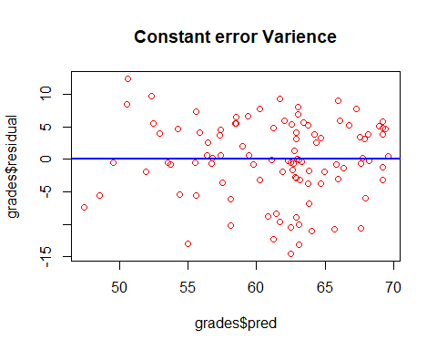

#What is Standard Error of Estimate of your model and how do you interpret the same. Show with some hypothetical values of predictors. Maximum 300 words. [hint: Standard Error of Estimate]  
fitted(model4)

## 1 2 3 4 5 6 7 8   
## 53.51437 57.54694 60.23375 64.69377 59.36711 69.20075 64.96854 67.88317   
## 9 10 11 12 13 14 15 16   
## 69.40038 65.95497 56.45719 63.01215 63.41141 55.55534 58.10591 57.33557   
## 17 18 19 20 21 22 23 24   
## 50.60446 58.13410 55.60700 63.77075 55.53186 69.20075 60.84439 60.23375   
## 25 26 27 28 29 30 31 32   
## 48.52828 52.32130 62.97222 61.73450 56.76487 62.61289 61.12387 65.68722   
## 33 34 35 36 37 38 39 40   
## 63.13193 61.25539 62.89709 64.05024 63.20004 59.42349 63.08027 68.96119   
## 41 42 43 44 45 46 47 48   
## 56.69675 59.75463 63.06853 67.28428 62.88063 47.40332 52.50448 65.98316   
## 49 50 51 52 53 54 55 56   
## 69.20075 59.01248 69.20075 63.78720 62.52601 62.57767 55.01282 65.80700   
## 57 58 59 60 61 62 63 64   
## 53.75393 54.26124 68.16266 57.41543 50.53634 56.40081 67.59195 67.92310   
## 65 66 67 68 69 70 71 72   
## 58.44880 55.87003 62.28174 63.83887 62.90882 67.59195 62.69274 58.50518   
## 73 74 75 76 77 78 79 80   
## 61.91066 51.95022 54.38573 69.20075 69.60001 62.49311 57.41543 61.41509   
## 81 82 83 84 85 86 87 88   
## 69.20075 67.76340 68.24251 63.85060 62.07037 69.20075 61.24365 64.68906   
## 89 90 91 92 93 94 95 96   
## 58.53337 52.97186 67.56376 62.49311 66.72531 62.92056 61.69458 66.11467   
## 97 98 99 100 101 102 103 104   
## 64.37436 62.81252 63.09200 66.36597 62.76557 49.55463 55.61874 63.33156   
## 105   
## 64.23813

## R Markdown

This is an R Markdown document. Markdown is a simple formatting syntax for authoring HTML, PDF, and MS Word documents. For more details on using R Markdown see <http://rmarkdown.rstudio.com>.

When you click the **Knit** button a document will be generated that includes both content as well as the output of any embedded R code chunks within the document. You can embed an R code chunk like this:

summary(cars)

## speed dist   
## Min. : 4.0 Min. : 2.00   
## 1st Qu.:12.0 1st Qu.: 26.00   
## Median :15.0 Median : 36.00   
## Mean :15.4 Mean : 42.98   
## 3rd Qu.:19.0 3rd Qu.: 56.00   
## Max. :25.0 Max. :120.00

## Including Plots

You can also embed plots, for example:



Note that the echo = FALSE parameter was added to the code chunk to prevent printing of the R code that generated the plot.